**WebScraping Project**

*by Rajat Bahuguna*

In this project, we will try to scrape relevant data from a given website and try to acquire the information which is relevant to us. We need to build this project in the following steps:

1. Go to the link: <https://store.steampowered.com/games/>
2. We need to scrape the details for the top 5 games in the “New and Trending Section” of the above website.
3. The details include: the name of the games,the number of reviews, their respective developer and publisher names, minimum requirements and 10 reviews for each game.

For our task, we will be using Scrapy which is an open source web-crawling framework in the Python programming language.

Our first step is to import all the modules from the python using import command. The image below shows all the frameworks and modules imported.

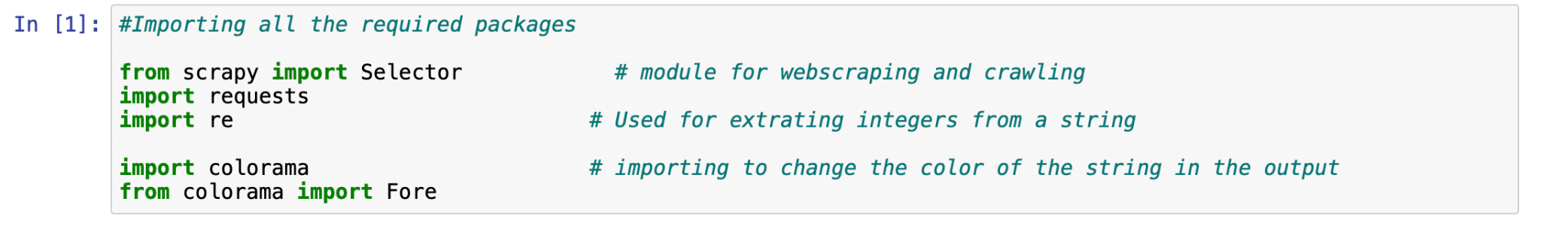

Then we simply select the url for which we want to get the top 5 games and define a selector which would eventually store all the html code in the url. The code below shows the url along with the selector used.



Now, to select all the top 5 games, we simply run a for loop which basically stores all the names of the games inside an empty list using the “Xpath” from the Selector which we defined as “sel” previously. And print the list of all the games. We can see the top games below as a list.

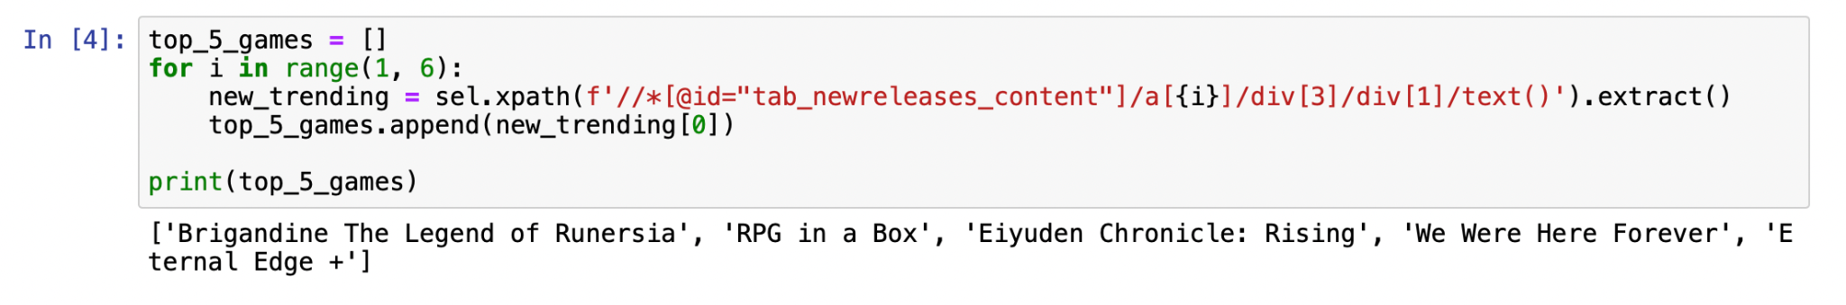

But, we also want all the urls of the top 5 games, in order to get further information we want to get from them, such as developer name, publisher name and other information.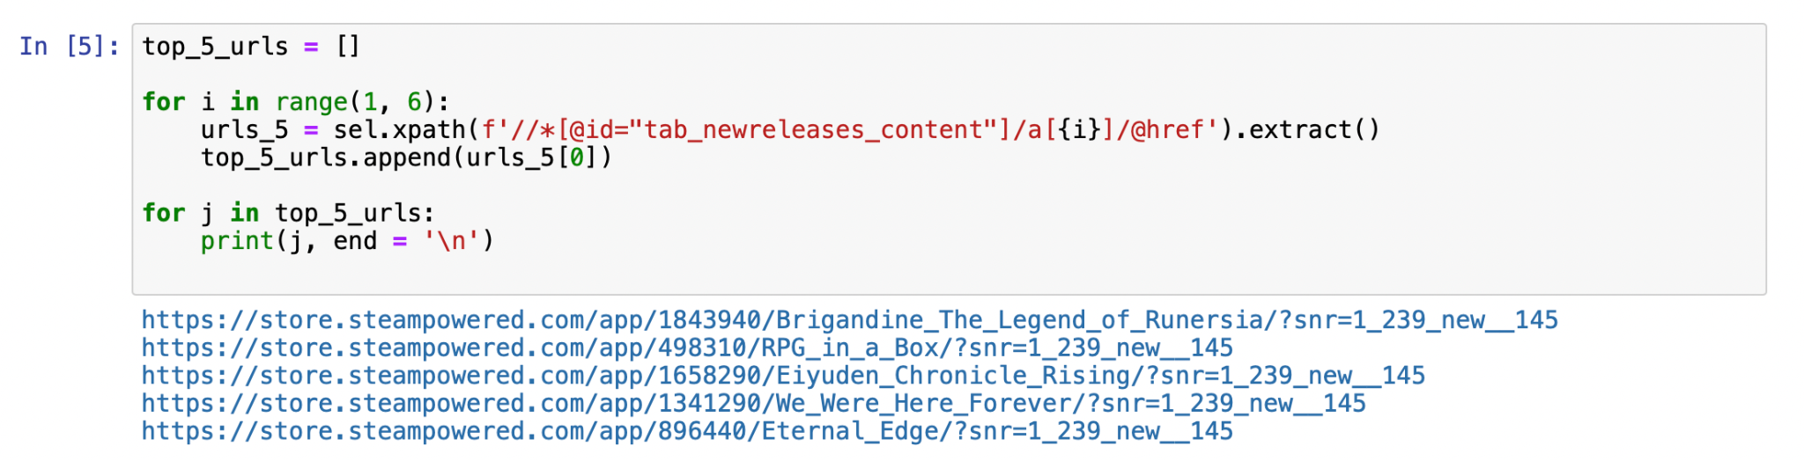

After getting all the links, now we just need to run a for loop along with the Xpaths for the respective texts for number of reviews, developer name and publisher name. And eventually print all of the information, in the form of a single string.

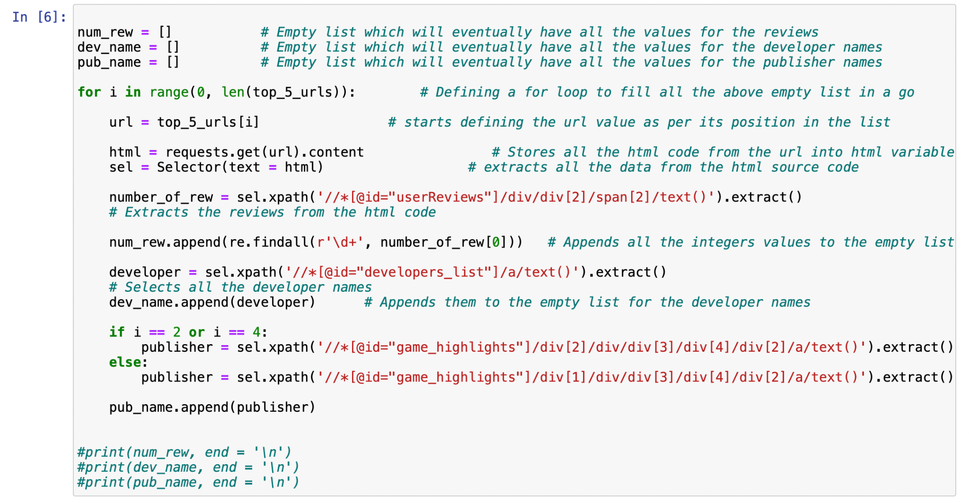

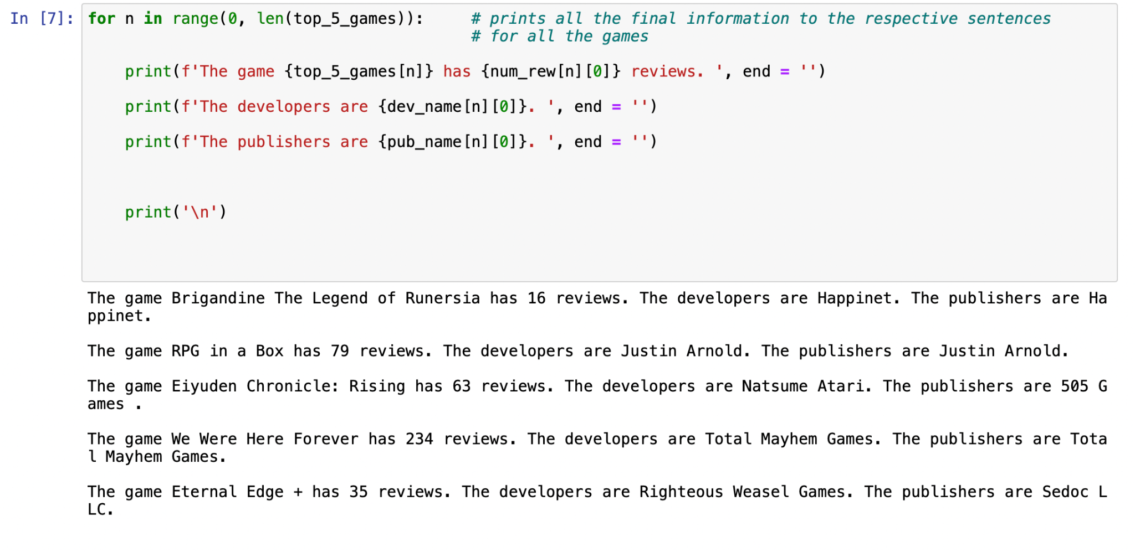

After getting all these values, we want minimum requirements for all the games. For this, we would again use the list having all the links for the games and scrape the details for the minimum requirements for the games. Below a snap of the code for finding the minimum (and recommended) requirements for the first game in the list.

Here, we change the color of the text for the recommended requirements for the game.

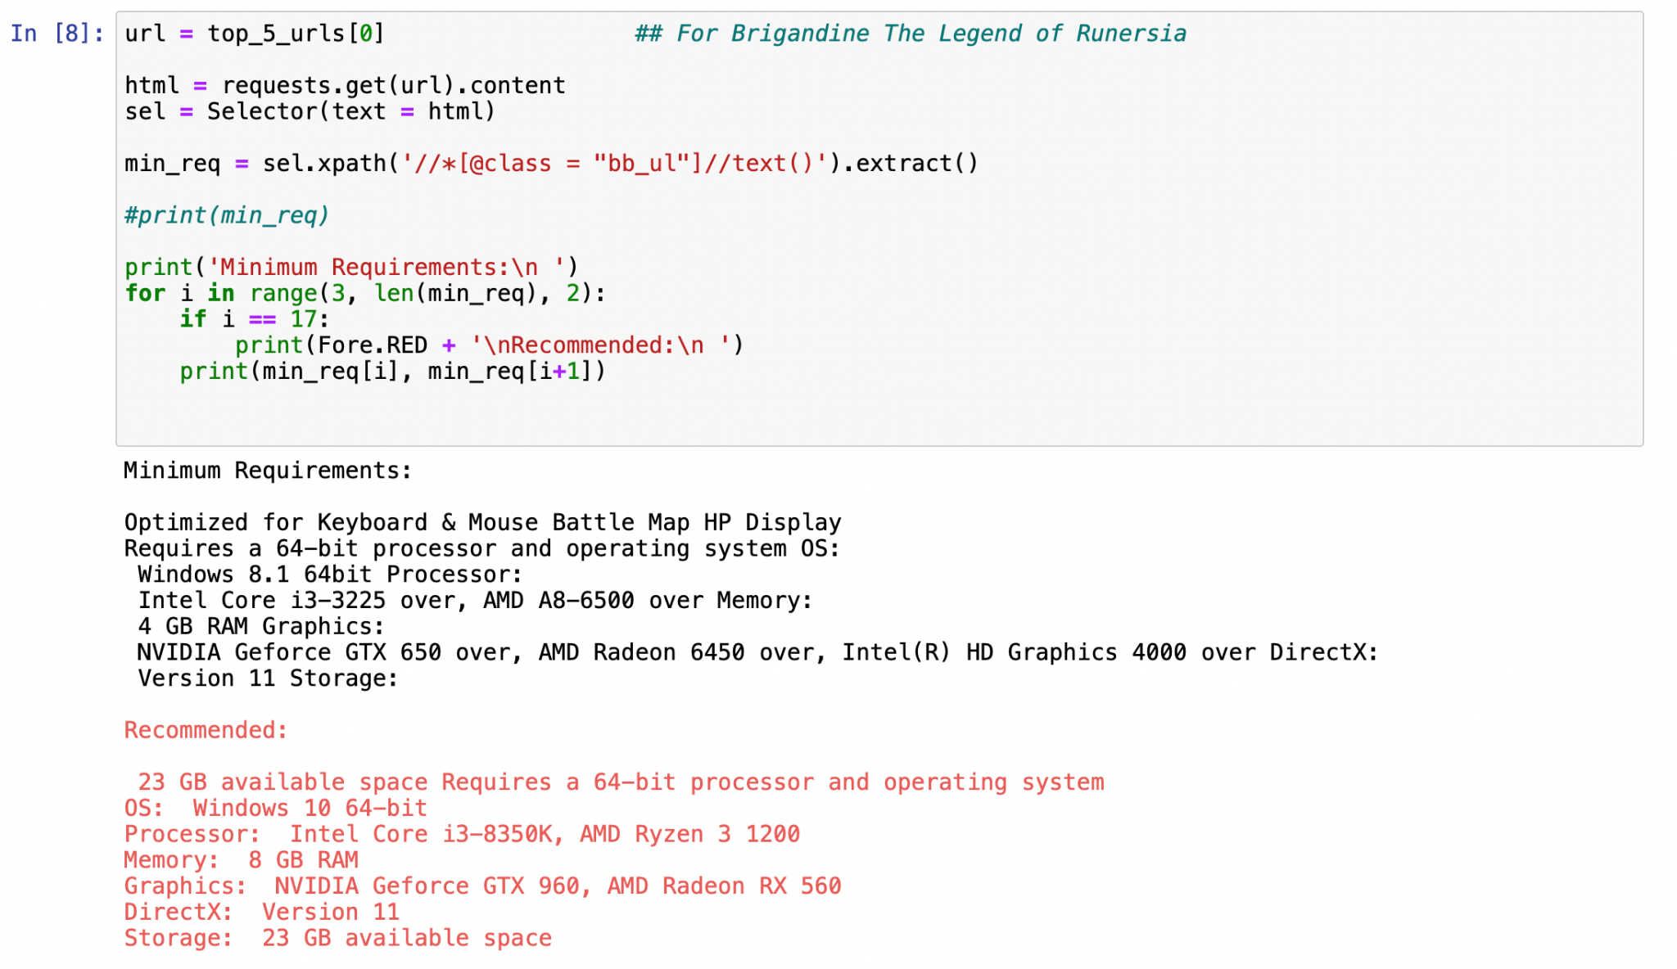

**Below is the entire Jupyter Notebook:**

Web Scraping Project

• Go to the link: https://store.steampowered.com/games/

• Find the top 5 “New and Trending Games”

• Find the name of their developers and Publisher names

• Find their respective minimum system requirements

• Find top 10 reviews from the website

#Importing all the required packages   
  
from scrapy import Selector # module for webscraping and crawling  
import requests   
import re # Used for extrating integers from a string  
  
import colorama # importing to change the color of the string in the output  
from colorama import Fore

url_2 = "https://store.steampowered.com/explore/new/" # Website url containing the top 5 trending games  
  
html = requests.get(url_2).content # Stores all the html code from the url into html variable  
sel = Selector(text = html) # extracts all the data from the html source code

#print(sel.xpath('//*')) # Selecting all the elements from the html code using Xpath

Selecting Top 5 Games as a list

top_5_games = []  
for i in range(1, 6):  
 new_trending = sel.xpath(f'//*[@id="tab_newreleases_content"]/a[{i}]/div[3]/div[1]/text()').extract()  
 top_5_games.append(new_trending[0])  
   
print(top_5_games)

['Brigandine The Legend of Runersia', 'RPG in a Box', 'Eiyuden Chronicle: Rising', 'We Were Here Forever', 'Eternal Edge +']

Now, we would try to get the url of these 5 games using scrapy

top_5_urls = []  
  
for i in range(1, 6):  
 urls_5 = sel.xpath(f'//*[@id="tab_newreleases_content"]/a[{i}]/@href').extract()  
 top_5_urls.append(urls_5[0])  
   
for j in top_5_urls:  
 print(j, end = '\n')

https://store.steampowered.com/app/1843940/Brigandine_The_Legend_of_Runersia/?snr=1_239_new__145  
https://store.steampowered.com/app/498310/RPG_in_a_Box/?snr=1_239_new__145  
https://store.steampowered.com/app/1658290/Eiyuden_Chronicle_Rising/?snr=1_239_new__145  
https://store.steampowered.com/app/1341290/We_Were_Here_Forever/?snr=1_239_new__145  
https://store.steampowered.com/app/896440/Eternal_Edge/?snr=1_239_new__145

num_rew = [] # Empty list which will eventually have all the values for the reviews  
dev_name = [] # Empty list which will eventually have all the values for the developer names  
pub_name = [] # Empty list which will eventually have all the values for the publisher names  
  
for i in range(0, len(top_5_urls)): # Defining a for loop to fill all the above empty list in a go  
  
 url = top_5_urls[i] # starts defining the url value as per its position in the list  
  
 html = requests.get(url).content # Stores all the html code from the url into html variable  
 sel = Selector(text = html) # extracts all the data from the html source code  
  
 number_of_rew = sel.xpath('//*[@id="userReviews"]/div/div[2]/span[2]/text()').extract()   
 # Extracts the reviews from the html code  
   
 num_rew.append(re.findall(r'\d+', number_of_rew[0])) # Appends all the integers values to the empty list  
  
 developer = sel.xpath('//*[@id="developers_list"]/a/text()').extract()  
 # Selects all the developer names  
 dev_name.append(developer) # Appends them to the empty list for the developer names  
   
 if i == 2 or i == 4:  
 publisher = sel.xpath('//*[@id="game_highlights"]/div[2]/div/div[3]/div[4]/div[2]/a/text()').extract()  
 else:  
 publisher = sel.xpath('//*[@id="game_highlights"]/div[1]/div/div[3]/div[4]/div[2]/a/text()').extract()  
   
 pub_name.append(publisher)  
   
   
#print(num_rew, end = '\n')  
#print(dev_name, end = '\n')  
#print(pub_name, end = '\n')

for n in range(0, len(top_5_games)): # prints all the final information to the respective sentences  
 # for all the games  
  
 print(f'The game {top_5_games[n]} has {num_rew[n][0]} reviews. ', end = '')  
   
 print(f'The developers are {dev_name[n][0]}. ', end = '')  
   
 print(f'The publishers are {pub_name[n][0]}. ', end = '')  
   
   
   
 print('\n')

The game Brigandine The Legend of Runersia has 16 reviews. The developers are Happinet. The publishers are Happinet.   
  
The game RPG in a Box has 79 reviews. The developers are Justin Arnold. The publishers are Justin Arnold.   
  
The game Eiyuden Chronicle: Rising has 63 reviews. The developers are Natsume Atari. The publishers are 505 Games .   
  
The game We Were Here Forever has 234 reviews. The developers are Total Mayhem Games. The publishers are Total Mayhem Games.   
  
The game Eternal Edge + has 35 reviews. The developers are Righteous Weasel Games. The publishers are Sedoc LLC.

## Find the Minimum requirements for all the games (also finding the recommended)

url = top_5_urls[0] ## For Brigandine The Legend of Runersia  
  
html = requests.get(url).content   
sel = Selector(text = html)   
  
min_req = sel.xpath('//*[@class = "bb_ul"]//text()').extract()  
  
#print(min_req)  
  
print('Minimum Requirements:\n ')  
for i in range(3, len(min_req), 2):  
 if i == 17:  
 print(Fore.RED + '\nRecommended:\n ')  
 print(min_req[i], min_req[i+1])

Minimum Requirements:  
   
Optimized for Keyboard & Mouse Battle Map HP Display  
Requires a 64-bit processor and operating system OS:  
 Windows 8.1 64bit Processor:  
 Intel Core i3-3225 over, AMD A8-6500 over Memory:  
 4 GB RAM Graphics:  
 NVIDIA Geforce GTX 650 over, AMD Radeon 6450 over, Intel(R) HD Graphics 4000 over DirectX:  
 Version 11 Storage:  
[31m  
Recommended:  
   
 23 GB available space Requires a 64-bit processor and operating system  
OS: Windows 10 64-bit  
Processor: Intel Core i3-8350K, AMD Ryzen 3 1200  
Memory: 8 GB RAM  
Graphics: NVIDIA Geforce GTX 960, AMD Radeon RX 560  
DirectX: Version 11  
Storage: 23 GB available space

url = top_5_urls[1] ## For RPG in a Box  
  
html = requests.get(url).content # Stores all the html code from the url into html variable  
sel = Selector(text = html)   
  
min_req = sel.xpath('//*[@class = "bb_ul"]//text()').extract()  
  
print('Minimum Requirements:\n ')  
for i in range(0, len(min_req), 2):  
 if i == 12:  
 print(Fore.RED + '\nRecommended:\n ')  
 print(min_req[i], min_req[i+1])

Minimum Requirements:  
   
OS: Windows 7  
Graphics: OpenGL 3.3+  
Storage: 500 MB available space  
OS: MacOS X 10.6  
Graphics: OpenGL 3.3+  
Storage: 500 MB available space  
[31m  
Recommended:  
   
OS: Any Distribution  
Graphics: OpenGL 3.3+  
Storage: 500 MB available space

url = top_5_urls[2] ## For Eiyuden Chronicle: Rising  
  
html = requests.get(url).content # Stores all the html code from the url into html variable  
sel = Selector(text = html)   
  
min_req = sel.css('.bb_ul ::text').extract()  
  
print('Minimum Requirements:\n ')  
for i in range(0, len(min_req)-1, 2):  
 if i == 14:  
 print(Fore.RED + '\nRecommended:\n ')  
 print(min_req[i], min_req[i+1])

Minimum Requirements:  
   
Requires a 64-bit processor and operating system OS:  
 Windows 7, 8.1, 10 x64 Processor:  
 AMD FX-4350 / Intel® Core™ i3-3210 Memory:  
 4 GB RAM Graphics:  
 AMD Radeon™ R7 260X (2GB VRAM) / NVIDIA® GeForce® GTX 750(2GB VRAM) Storage:  
 20 GB available space Additional Notes:  
 30+ FPS @ 1280x720 and graphics pre-set "LOW (minimum quality)" Requires a 64-bit processor and operating system  
[31m  
Recommended:  
   
OS: Windows 7, 8.1, 10 x64  
Processor: AMD Ryzen™ 5 1700 / Intel® Core™ i7-4770S  
Memory: 6 GB RAM  
Graphics: Radeon™ RX 470(4GB VRAM) / NVIDIA® GeForce® GTX 1060 6 GB VRAM  
Storage: 20 GB available space  
Additional Notes: Expected Framerate: 60 FPS @ 1920x1080 - You may be aiming for Very High (highest quality), but you may end up with Standard (standard quality). - The GPU specification may be raised in the special note as 4K is not capable of 60FPS with this setup.

url = top_5_urls[3] ## For We Were Here Forever  
  
html = requests.get(url).content # Stores all the html code from the url into html variable  
sel = Selector(text = html)   
  
min_req = sel.xpath('//*[@class = "bb_ul"]//text()').extract()  
  
print('Minimum Requirements:\n ')  
for i in range(45, len(min_req), 2):  
 if i == 55:  
 print(Fore.RED + '\nRecommended:\n ')  
 print(min_req[i], min_req[i+1])

Minimum Requirements:  
   
 A working PC-compatible microphone Requires a 64-bit processor and operating system  
OS: Windows 10 64 bit  
Processor: Intel Core i5 4000 series or equivalent  
Memory: 8 GB RAM  
Graphics: Nvidia GTX 970 or equivalent, integrated graphics not supported  
[31m  
Recommended:  
   
DirectX: Version 12  
Network: Broadband Internet connection  
Storage: 25 GB available space  
Additional Notes: A working PC-compatible microphone

url = top_5_urls[4] ## For Eternal Edge +  
  
html = requests.get(url).content # Stores all the html code from the url into html variable  
sel = Selector(text = html)   
  
min_req = sel.xpath('//*[@class = "bb_ul"]//text()').extract()  
  
print('Minimum Requirements:\n ')  
for i in range(0, len(min_req), 2):  
 if i == 14:  
 print(Fore.RED + '\nRecommended:\n ')  
 print(min_req[i], min_req[i+1])

Minimum Requirements:  
   
Travel to far off lands Fight Epic Monsters  
Uncover mysterious areas And save the good people from a reign of evil!  
OS: Windows 10  
Processor: Intel Core i5  
Memory: 4 GB RAM  
Graphics: Intel HD Graphics 3000 or better  
DirectX: Version 10  
[31m  
Recommended:  
   
Storage: 4 GB available space  
OS: Windows 10  
Processor: Intel Core i7 or Higher  
Memory: 4 GB RAM  
Graphics: Nvidia Geforce GTX 760/equivalent or higher  
DirectX: Version 10  
Storage: 4 GB available space

### End: Thank You!!!